OUTREACH NOTICE
AVALANCHE FORECASTER/
BACKCOUNTRY-WILDERNESS MANAGER
GS-462-7/8

White Mountain National Forest
Androscoggin Ranger District

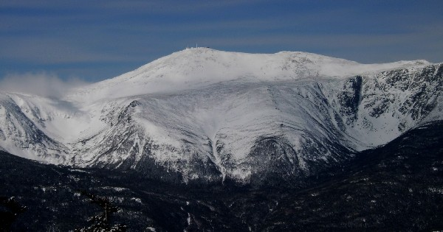
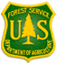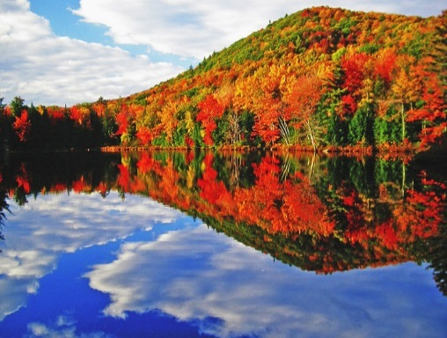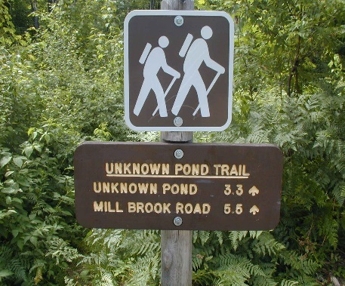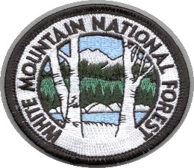

Reply by August 25th – (See Outreach reply at bottom)

The White Mountain National Forest (WMNF) will soon be advertising to fill one Forestry Technician (Snow Ranger/Avalanche Specialist-Wilderness/Backcountry Program Manager) on the Androscoggin Ranger District in Gorham, New Hampshire. The position will be advertised as a GS-0462-07/08 career ladder and could be filled at either grade. The purpose of the outreach is to notify potential candidates about this upcoming position. If you are interested in applying please fill out the attached response form and return to: Frank Carus, Lead Snow Ranger, at fscarus@fs.fed.us. For more information about the position please contact Frank at this email.

This position has varied and very different responsibilities depending on the season. From December until the end of May, the incumbent works as part of the motivated and effective Snow Ranger team that issues daily avalanche advisories, performs Search and Rescue missions for the Forest Service as Lead Agency in command, and increases visitor knowledge through avalanche education programs of varying media. From late May until the snow begins to fly again in the late fall, the incumbent supervises a crew of Backcountry Rangers in the performance of duties related to dispersed recreation management on the District and serves as the lead for three wilderness areas. This includes long field days, interacting with the public, management of volunteers, and maintenance of backcountry recreation facilities.
Snow Ranger/Avalanche Specialist Duties
In the winter months, producing an accurate and timely avalanche and mountain hazards advisory for the visiting public is the focused priority each day. The position will determine present avalanche hazard and forecast future hazards based on field observations and snow stability analysis. Analysis will utilize field observations paired with an intimate knowledge of snow metamorphism, snow physics, and mechanics of slab fracture and failure. In addition, knowledge of mountain weather forecasting tools such as weather maps, satellite imagery, and real time weather data is necessary to produce forecasts of the highest standards. The candidate must have the ability to quickly synthesize data and disseminate this information in writing through the avalanche center website, social media and in person to forest visitors. Excellent writing skills that accurately convey the hazards of the day are paramount.

Additionally, the Forest Service serves as the lead agency in charge of SAR operations on the east side of Mount Washington from December 1st to June 1st of each year. Avalanche specialists may act as a first responder, searcher, team leader, technical team leader and even Incident Commander on smaller incidents. Numerous Forest Service volunteer SAR teams respond to assist with missions that are managed by the Snow Rangers. Strong leadership and personnel management skills are required to effectively oversee safe operations of teams during hazardous and potential stressful circumstances. Incidents typically include ice climbing or mountaineer falls in Huntington Ravine, avalanche burials, searches for lost or overdue winter hikers, and traumatic ski injuries. The spring ski season may bring 2500 people or more to Tuckerman Ravine on a sunny day in April or May. Due to these responsibilities current EMT certification and experience is desired while climbing and technical rope rescue skills are also beneficial.

The dedication required for this position requires a unique enthusiasm for harsh winter weather and the ability to work well in a difficult environment while helping visitors enjoy Mount Washington. The summit records many days through each winter with winds in excess of 100mph and temperatures lower than -25F. Due to these weather conditions the position requires excellent physical fitness to maintain a margin of safety during searches in severe conditions as well as while collecting the field data required for accurate avalanche forecasts.

The ideal candidate should have the ability to teach avalanche safety, stability analysis and snow mechanics to a wide variety of audiences from school children to seasoned recreationalists. Venues include slide shows, field snow pits, and seminar settings. The position must stay abreast of avalanche education practices and changes in avalanche technology and snow science. The candidate must possess good public speaking and teaching skills.

In addition to solid ski mountaineering skills, sound mountaineering and ice climbing skills are needed to access all potential areas to assess snow stability as well as injured climbers. Candidates may be required to lead climb water ice to render medical and technical assistance to individuals in the event of an accident. Good mountaineering skills are needed on a regular basis to carry out a variety of Snow Ranger tasks across the mountain. Snow Rangers also operate and maintain snowmobiles, ATV’s, and a diesel Pisten Bully Snowcat. Experience with this equipment is very beneficial.

This is a field-going position focused on field contacts during a five day work week. Being available to provide good information and advice about current hazards, avalanche conditions, route selections, mountain weather and being close to the interface between visitors and the mountain is critical. Current Snow Rangers make up a team of open, forward-thinking, and creative problem solvers that attempt to continually improve their knowledge through sharing and collaborating with one another. They are team focused to get the job done and put themselves behind the group in that effort. The Snow Rangers care about the visitors they are there to help and provide unique services with a mission to promote safety while caring for and promoting backcountry values of environmental protection and stewardship.

Open the following link to review a detailed history of the Avalanche Center and the recreational and social use on the mountain. It also discusses the unique avalanche forecasting factors associated with Mount Washington. http://www.mountwashingtonavalanchecenter.org/about-2/

From June until November, the position focuses on managing the Backcountry and Wilderness Program on the District. Overall the job responsibilities exist year round so some summer planning for Wilderness, trails and backcountry is required in winter as does Snow Ranger preperation occur in the summer.

Backcountry/Wilderness Position Duties
- Supervises and manages 3 units of National Wilderness preservation system.
- Oversees and supervises seasonal backcountry and wilderness personnel. Responsible for health and safety, administration, training, and quality assurance of work for assigned personnel. Includes all aspects of interviewing and hiring process.
- Responsible for backcountry facilities construction and maintenance. This includes planning, organizing and implementing major construction projects at remote locations. Includes maintenance and construction of human waste composting toilets. Serves as the project specialist for maintenance and construction activities.
- Performs condition surveys, cost estimates, safety inspections and makes recommendations for improvements at developed and undeveloped backcountry areas.
- Responsible for dispersed backcountry sign program, including construction of new trail signs. Assures that all trailhead facilities, signs and bulletin boards are in top condition and contain necessary information.
- Interacts with public in remote settings to inform visitors of Forest regulations, low impact camping techniques and “Leave No Trace” recommendations.
- Responsible for posting of regulations, reporting incidents and issuing violation notices. Ensure field compliance for Outfitter/guide permits.
- Works with a variety of volunteer organizations, interested individuals and cooperators to reach the goals of the program. Manages large volunteer work parties an efforts.
- Assists in implementation of Wilderness Management Plans based on directions in Forest Plan and assists with annual reporting requirements.
- Works with peers on other Districts to develop programs at the Forest level.
DISTRICT INFORMATION

The Androscoggin Ranger District is located in Coos County, New Hampshire and Oxford County, Maine. The primary office is in Gorham, New Hampshire and was built in 1996. The WMNF is visited by approximately 7 million people each year, and is considered one of the northeast’s crown jewels. Our visitors and local communities have a long history of caring for the forest in the White Mountains: they were the driving force behind the 1911 Weeks Act, under which the WMNF was purchased. This strong interest in the management of these lands continues today, and is demonstrated through the substantial number of partnerships and cooperative agreements that exist on the Forest.

The Presidential Range of the White Mountains offers a stunning alpine backdrop to the quiet villages in the river valleys of northern New Hampshire and western Maine. Outdoor sports opportunities are endless while our scenery is unsurpassed. The phrase "If you don't like the weather, wait a minute, it'll change," was created in New England. Northern New Hampshire and western Maine have a history of bizarre and unpredictable weather patterns. The summit of Mount Washington is the official home of "The World's Worst Weather", winds up to 231mph have been documented. In general, there are four distinct seasons with cold winters, wet and muddy springs, relatively cool summers and glorious falls. Tuckerman Ravine is well known for extreme skiing in the spring and Huntington Ravine is well known for ice climbing. Access to both areas requires fairly arduous hikes of over 3 miles from the nearest year round road and our Snow Ranger program provides avalanche forecasting for these two destinations.

Recreation activities, facilities, and programs on the District include: five fee campgrounds (four of which are managed by concession); three Wilderness areas; numerous day use areas; extensive dispersed backcountry and Wilderness camping; over 440 miles of four-season trails (including a substantial portion of the Appalachian Trail) that receive various uses including hiking, snowmobiling, snowshoing, cross-country skiing, and mountain biking; rock and ice climbing; several swimming areas; backcountry cabins; a network of backcountry shelters and tent sites; and several National Register historic sites.

COMMUNITY INFORMATION

Gorham has a population of about 2,800 and the nearby city of Berlin has a population of about 9,600. The economy of the area is split between recreation and forest products. Both communities recognize the value of a “working forest” to provide a variety of needs for the public. Both Gorham and Berlin have public schools through high school. Nearby Bethel, Maine, hosts a private high school. Berlin also hosts the White Mountain Community College, one of seven community colleges integrated with the state university system. Hospital facilities are located in Berlin while Gorham hosts a medical clinic. There are several banks and credit unions in the area. Churches for just about every Christian denomination are present but places of worship for other faiths are absent. There is diversity among the predominantly Caucasian population with French being a common language, especially in Berlin. Additional community options include Jackson, Bartlett and North Conway to the south.

New Hampshire is the "Live Free or Die" State, but it isn't completely free. There are no State income or sales taxes. To make up for that, property taxes can be high. Each community is different, so checking them out can be a deciding factor when buying a home. Houses in the area rent for about $600-$1200 per month and sell for $75,000 to $200,000+. There are numerous homes for sale in the area and with patience, excellent buys can be found. Home prices and rentals are generally higher in the communities to the south.

The White Mountain Region is a four-season recreation destination. Recreational opportunities are numerous, including summer activities of camping, hiking, climbing, biking, fishing - both lakes and rivers, boating, swimming, surfing - the Atlantic Ocean is a short drive (about 2 hours), wildlife watching, tax-free shopping, picnicking, the arts and other forms of entertainment too numerous to mention. During the winter months hunting, downhill and cross-country skiing, snowmobiling, winter mountaineering, ice climbing and other winter sports are popular. There are many ski resorts within easy driving distance of Gorham including Wildcat, Attitash-Bear Peak, Bretton Woods, Sunday River, and Cannon. Backcountry skiing can be found above treeline and in the slide paths across the Presidential Range and beyond. Several world class Nordic centers serve cross-country skiers including: Jackson Ski Touring, Great Glen Trails, Bretton Woods, Bear Notch, and Mt. Washington Valley Ski Touring.

OUTREACH REPLY to fscarus@fs.fed.us

GS-462-7/8 Snow Ranger/Avalanche Specialist-Backcountry/Wilderness

SUBMISSION OF THIS INFORMATION IS VOLUNTARY

NAME:

E-MAIL ADDRESS:

MAILING ADDRESS:

TELEPHONE NUMBER:

CURRENT REGION/FOREST/DISTRICT (if applicable):

CURRENT SERIES AND GRADE (if applicable):

CURRENT POSITION TITLE:

OTHER INFORMATION, INCLUDING RELATED SKILLS AND EXPERIENCE:

SUBMISSION OF THIS INFORMATION IS VOLUNTARY

Thank You for Your Interest!

We will notify those who respond to the outreach notice when the vacancy announcement is posted on USAJOBS automated application system. The vacancy will be advertised at http://www.usajobs.gov. Interested candidates are encouraged to prepare a resume and create a USA Jobs profile, prior to the posting of the vacancy announcement. All applicants must meet the Office of Personnel Management (OPM) qualification standards for General Schedule positions, to be considered eligible for this position. Qualifications requirements are available from any Federal Government Personnel Office and OPM website (http://www.opm.gov/qualifications.index.asp).
HOW TO APPLY: go to https://www.usajobs.gov/
Step 1 — Create a USAJOBS account (if you do not already have one). It is recommended that as part of your profile you set up automatic email notification to be informed when the status of your application changes. If you choose not to set up this automatic notification, you will need to log into your USAJOBS account to check on the status of your application.
Step 2 — Create a resume with USAJOBS or upload a resume into your USAJOBS account profile. You may want to customize your resume to ensure it accurately depicts your duties and accomplishments as they pertain to the position for which you’re applying. Include accurate information about the length of time you performed such duties as it is a key factor in determining whether or not you qualify for a specific grade. In addition, your resume must support your responses to the online questionnaire (you may preview the online questionnaire by clicking on the link at the end of the “How You Will Be Evaluated” section of the job announcement.
Step 3 — Search for the job announcement number or simply click on the provided hyperlink. Please read the entire announcement and all the instructions before you begin. Click “Apply Online” and follow the prompts to complete the “Occupational Questionnaire” and attach any additional documents that may be required.
You may update your application or documents anytime while the announcement is open. Simply log into your USAJOBS account and click on “Application Status.” Click on the position title, and then select “Update Application” to continue.
◻ If you need assistance with navigating through the USAJOBS website, please visit: https://help.usajobs.gov/index.php/Main_Page

